**Id code:** 19CM029 **Name:** Dhiraj Jagtap **Sem:** 5th

**Practical No: 8**

**Aim:** Write simple PHP program to -

a. Set cookies and read it.

b. Demonstrate session Management.

**Procedure:**

1. **Set cookies and read it.**

**Theory:**

A cookie is often used to identify a user. A cookie is a small file that the server embeds on the user's computer. Each time the same computer requests a page with a browser, it will send the cookie too. With PHP, you can both create and retrieve cookie values.

Create Cookies With PHP

A cookie is created with the setcookie() function.

**Syntax:**

setcookie(name, value, expire, path, domain, secure, httponly);

Only the name parameter is required. All other parameters are optional.

PHP Create/Retrieve a Cookie

The following example creates a cookie named "user" with the value "John Doe". The cookie will expire after 30 days (86400 * 30). The "/" means that the cookie is available in entire website (otherwise, select the directory you prefer).

We then retrieve the value of the cookie "user" (using the global variable $_COOKIE). We also use the isset() function to find out if the cookie is set:

**Program:**

<?php

$cookie_name = "user";

$cookie_value = "Dhiraj";

setcookie($cookie_name, $cookie_value, time() + (86400 * 30), "/"); // 86400 = 1 day

?>

<html>

<body>

<?php

if(!isset($_COOKIE[$cookie_name])) {

  echo "Cookie named '" . $cookie_name . "' is not set!";

} else {

  echo "Cookie '" . $cookie_name . "' is set!<br>";

  echo "Value is: " . $_COOKIE[$cookie_name];

}

?>

</body>

</html>

**Output:**

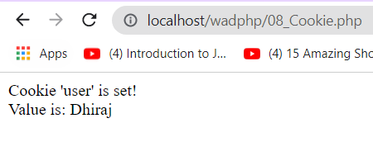

1. **Demonstrate Session Management**

**Theory:**

A session is a global variable stored on the server.

Each session is assigned a unique id which is used to retrieve stored values.

Whenever a session is created, a cookie containing the unique session id is stored on the user’s computer and returned with every request to the server. If the client browser does not support cookies, the unique php session id is displayed in the URL

Sessions have the capacity to store relatively large data compared to cookies.

The session values are automatically deleted when the browser is closed. If you want to store the values permanently, then you should store them in the database.

Just like the $_COOKIE array variable, session variables are stored in the $_SESSION array variable. Just like cookies, the session must be started before any HTML tags.

**Program:**

**Output:**

First Load

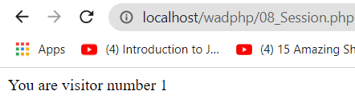

Second Load



**Conclusion:** hence, we have gone through the Session management and performed a program which shows the no. of users visited the webpage.